3.2 Training Data Set Creation
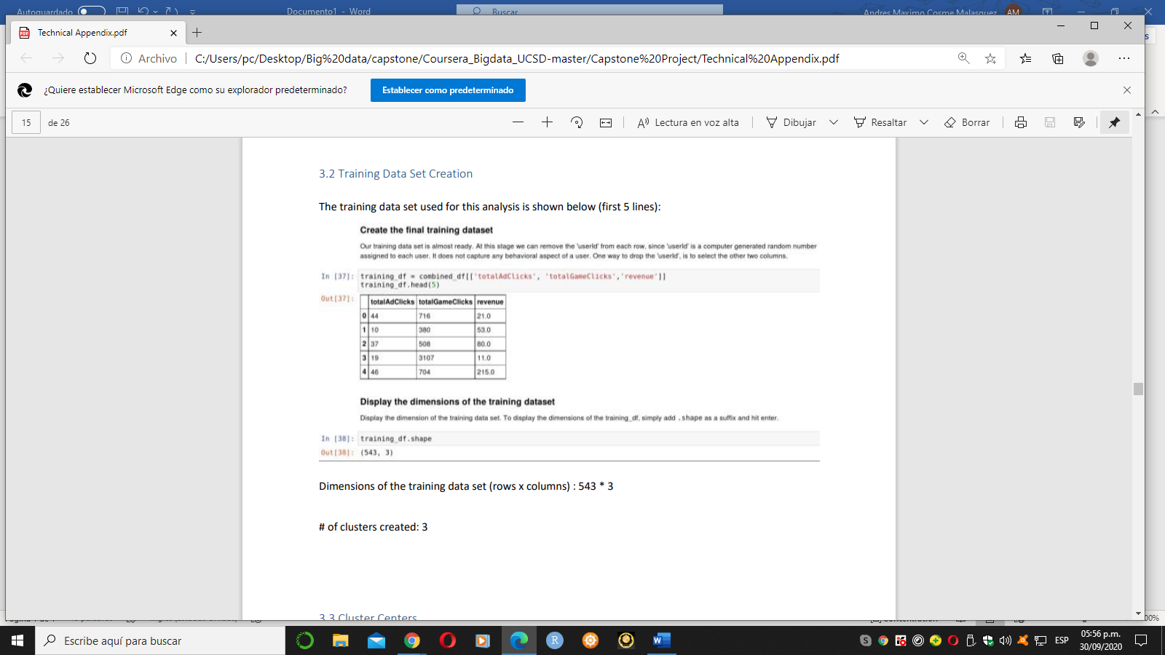
The training data set used for this analysis is shown below (first 5 lines):

Dimensions of the training data set (rows x columns) : 543 * 3
# of clusters created: 3

